**Institute of Engineering & Management**

**Department of Computer Science & Engineering**

**Object Oriented Programming (IT) Lab for 3rd year 5th semester 2018**

**Code: CS594D**

**Date:** 21/08/18

**WEEK-7**

**Assignment-1**

**Problem Statement:** Implement Linked List in Java

**Source code:**

import java.util.Scanner;

class LinkedList{

private Node head;

private int size;

LinkedList()

{

this.head = null;

this.size = 0;

}

void insert_begin(int num)

{

Node newNode = new Node(num, head);

this.head = newNode;

this.size++;

}

void insert_end(int num)

{

Node newNode = new Node(num, null), temp = this.head;

if(this.head == null)

this.head = newNode;

else{

while(temp.next != null)

temp = temp.next;

temp.next = newNode;

}

this.size++;

}

void insert(int num, int pos)

{

Node temp = this.head;

if(pos < 0 || pos > size)

{

System.out.println("invalid position!");

return;

}

if(pos == 0)

{

insert_begin(num);

return;

}

while(pos!=1 && temp!=null)

{

temp = temp.next;

pos--;

}

Node newNode = new Node(num, temp.next);

temp.next = newNode;

this.size++;

}

void delete(int num)

{

Node temp = this.head, prev = this.head;

while(temp!=null)

{

if(temp.num == num)

break;

prev = temp;

temp = temp.next;

}

if(temp == null)

{

System.out.println("No such element present!");

return;

}

if(temp == this.head)

head = head.next;

else prev.next = temp.next;

this.size--;

}

void display()

{

Node temp = this.head;

if(this.head == null)

{

System.out.println("Empty!");

return;

}

System.out.print("List elements:");

while(temp != null)

{

System.out.print(" "+temp.num);

temp = temp.next;

}

System.out.println();

}

}

class Node{

int num;

Node next = null;

Node(int num, Node next)

{

this.num = num;

this.next = next;

}

}

class Main{

public static void main(String args[])

{

LinkedList list = new LinkedList();

System.out.println("The Linked List Commands:");

System.out.println(" 1:Insert at beginning\n 2:Insert at end\n 3:Insert at a particular position\n 4:Delete element\n 5:Display all the elements\n 6:Exit");

Scanner sc = new Scanner(System.in);

int flag = 0;

do{

System.out.print("Enter the Command: ");

int op = sc.nextInt();

switch(op)

{

case 1: System.out.print("Enter the element: ");

list.insert_begin(sc.nextInt()); break;

case 2: System.out.print("Enter the element: ");

list.insert_end(sc.nextInt()); break;

case 3: System.out.print("Enter the element & the position respectively (space separated):);

list.insert(sc.nextInt(),sc.nextInt());break;

case 4: System.out.print("Enter the element to delete: ");

list.delete(sc.nextInt()); break;

case 5: list.display(); break;

case 6: flag = 1; break;

default: System.out.println("Invalid Input!");

}

}while(flag == 0);

sc.close();

}

}

**Screen-Shot:**

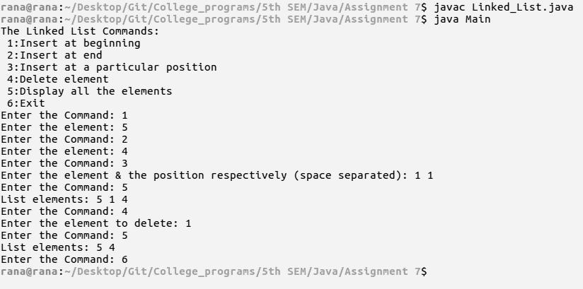

**Fig: Linked-List**